**STP CONCEPTS**

5.0.1

Why should I take this module?

Welcome to STP Concepts!

A well-designed Layer 2 network will have redundant switches and paths to ensure that if one switch goes down, another path to a different switch is available to forward data. Users of the network would not experience any disruption of service.

Redundancy in a hierarchical network design fixes the problem of a single point of failure, yet it can create a different kind of problem called ***Layer 2 loops.***

What is a loop? Imagine that you are at a concert. The singer’s microphone and the amplified loudspeaker can, for a variety of reasons, create a feedback loop. What you hear is an amplified signal from the microphone that comes out of the loudspeaker which is then picked up again by the microphone, amplified further, and passed again through the loudspeaker. The sound quickly becomes very loud, unpleasant, and makes it impossible to hear any actual music. This continues until the connection between the microphone and the loudspeaker is cut.

A Layer 2 loop creates similar chaos in a network. It can happen very quickly and make it impossible to use the network. There are a few common ways that a Layer 2 loop can be created and propagated.

***Spanning Tree Protocol (STP)*** is designed specifically to eliminate Layer 2 loops in your network. This module discusses causes of loops and the various types of spanning tree protocols. It includes a video and a Packet Tracer activity to help you understand STP concepts.

5.0.2

What will I learn to do in this module?

**Module Title**: STP Concepts

**Module Objective**: Explain how STP enables redundancy in a Layer 2 network.

| Table caption | |
| --- | --- |
| **Topic Title** | **Topic Objective** |
| **Purpose of STP** | Explain common problems in a redundant, L2 switched network. |
| **STP Operations** | Explain how STP operates in a simple switched network. |
| **Evolution of STP** | Explain how Rapid PVST+ operates. |

**PURPOSE OF STP**

5.1.1

Redundancy in Layer 2 Switched Networks

This topic covers the causes of loops in a Layer 2 network and briefly explains how spanning tree protocol works.

Redundancy is an important part of the hierarchical design for eliminating single points of failure and preventing disruption of network services to users. Redundant networks require the addition of physical paths, but logical redundancy must also be part of the design.

Having alternate physical paths for data to traverse the network makes it possible for users to access network resources, despite path disruption. However, redundant paths in a switched Ethernet network may cause both physical and logical Layer 2 loops.

Ethernet LANs require a loop-free topology with a single path between any two devices. A loop in an Ethernet LAN can cause continued propagation of Ethernet frames until a link is disrupted and breaks the loop.

5.1.2

## Spanning Tree Protocol

Spanning Tree Protocol (STP) is a loop-prevention network protocol that allows for redundancy while creating a loop-free Layer 2 topology. IEEE 802.1D is the original IEEE MAC Bridging standard for STP.

Click Play in the figure to view an animation of STP in action.

### **STP Normal Operation**

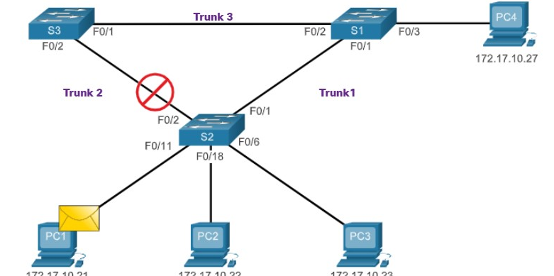

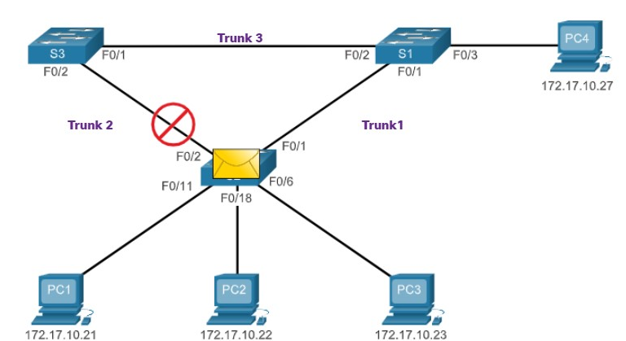

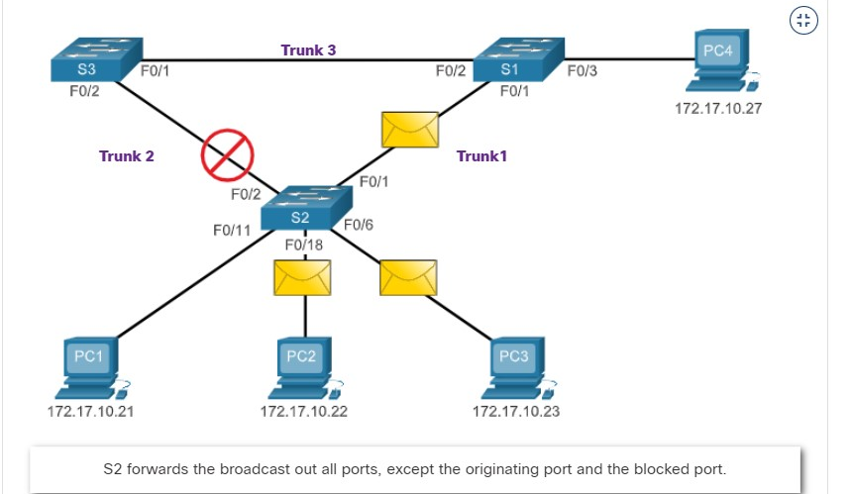

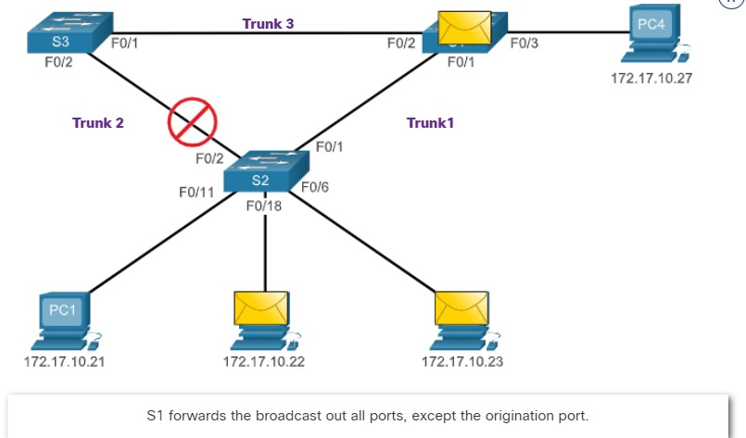

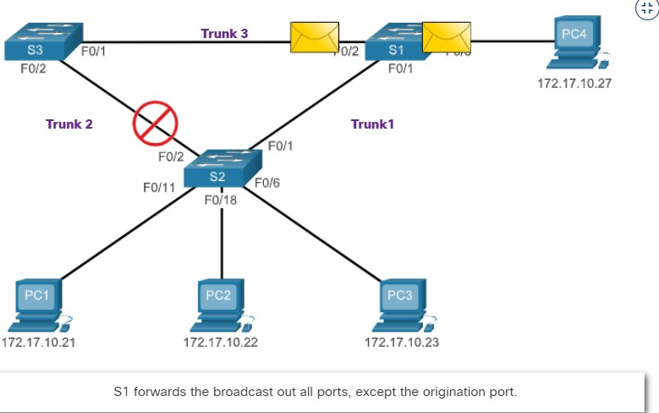

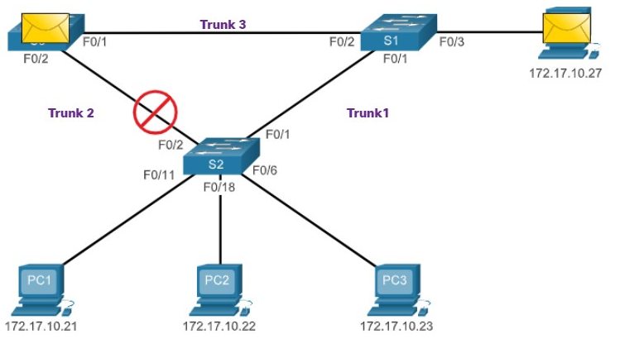

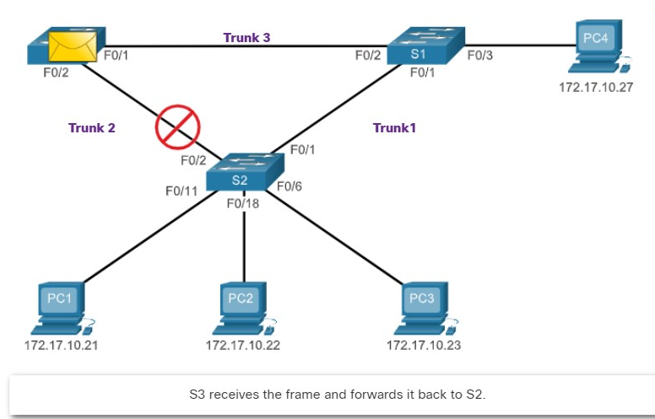

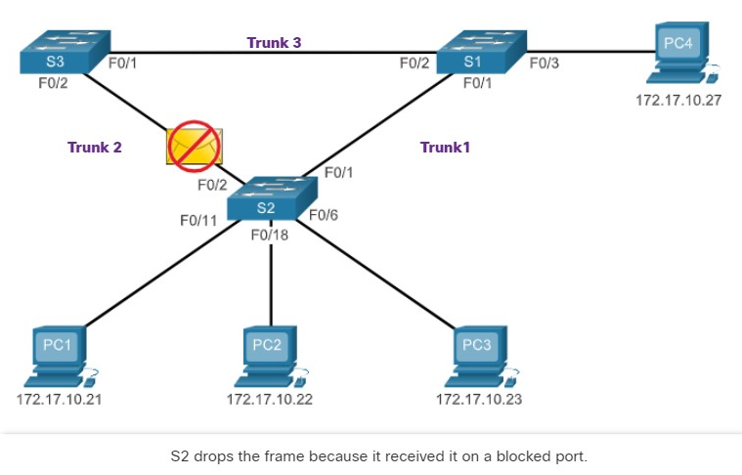

5.1.3

## STP Recalculation

Click Play in the next figure to view an animation of STP recalculation when a failure occurs.

The figure is an animation with the same topology as in the previous animation. In the animation, the trunk link between S 2 and S 1 has failed.

S 2 unblocks the port for Trunk 2. P C1 sends a broadcast frame to S 2. S 2 forwards the broadcast out all switch ports, except the originating port and the failed link for Trunk 1. S 3 forwards the broadcast out all available switch ports, except the originating port. S 1 forwards the broadcast only out of F0/3.

### **STP Compensates for Network Failure**

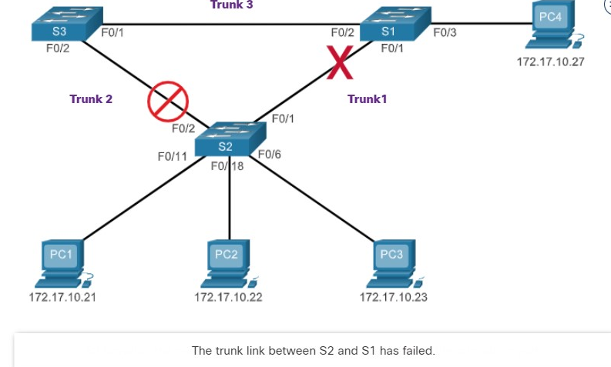

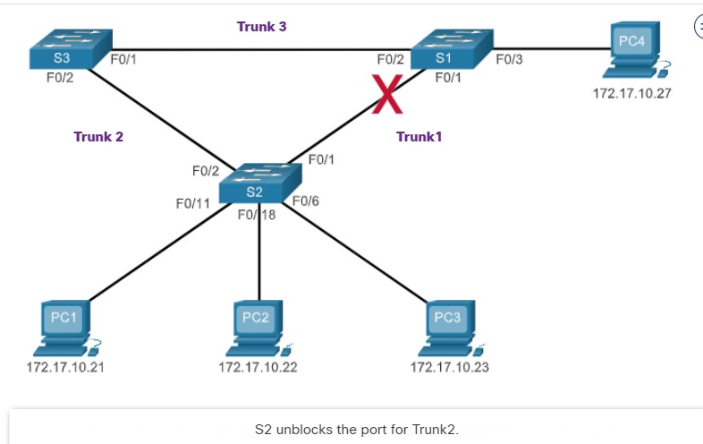

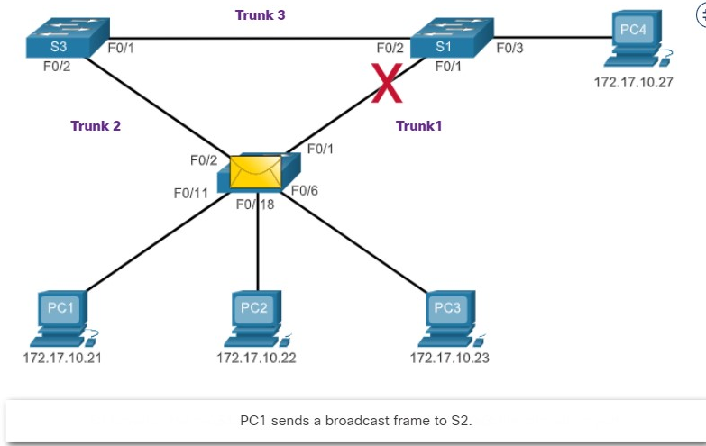

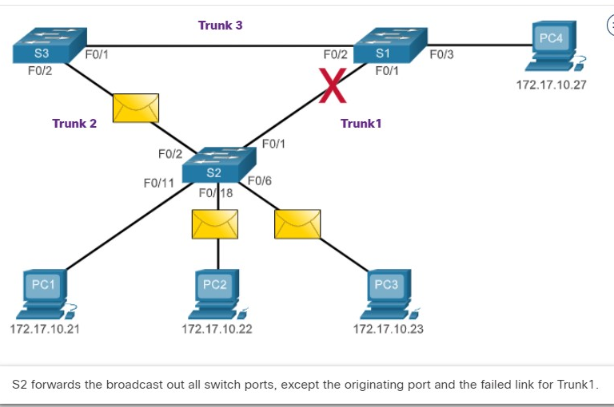

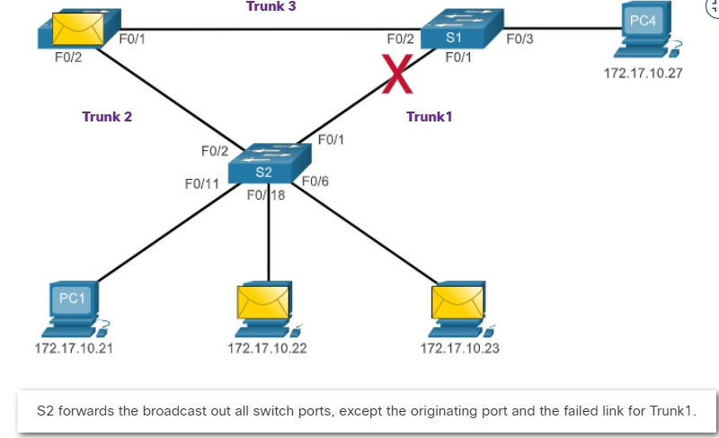

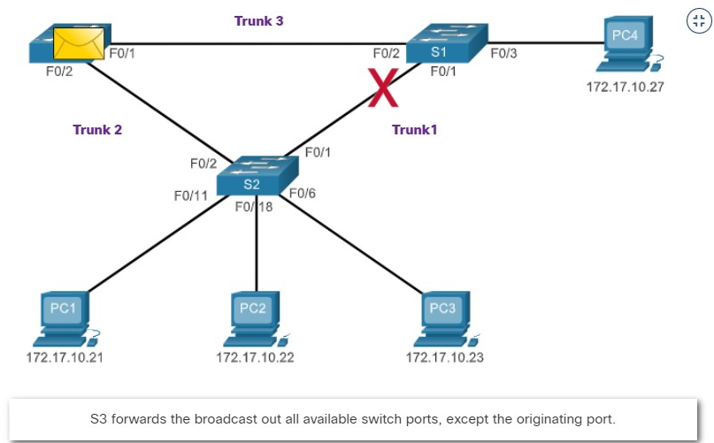

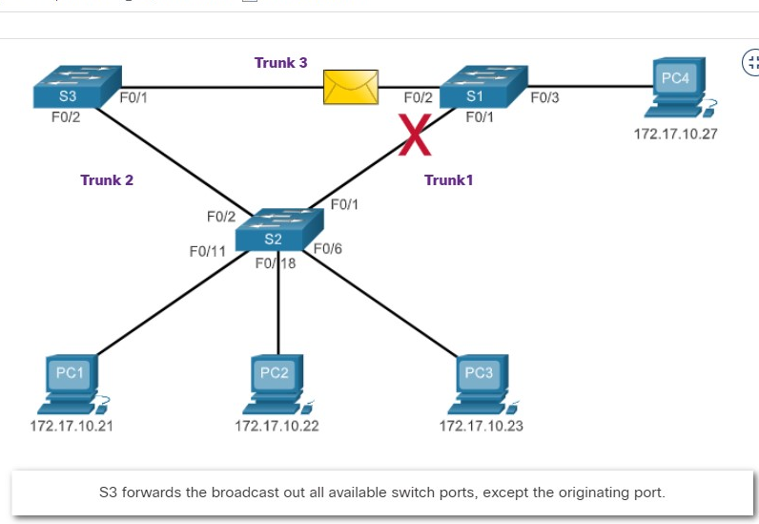

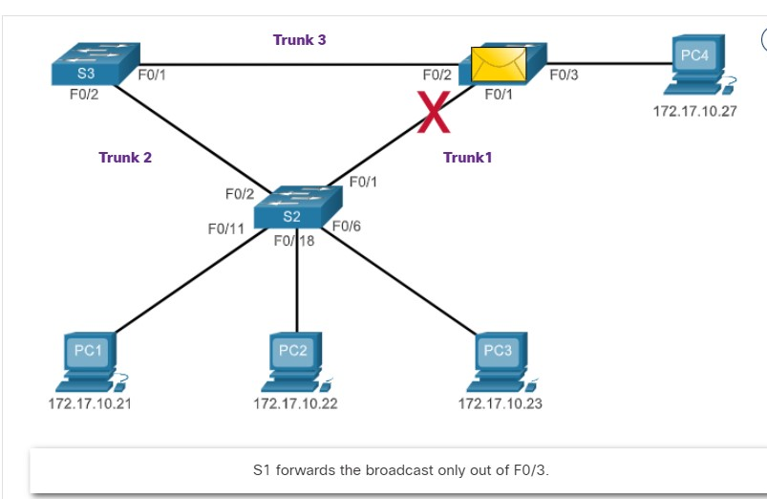

5.1.4

Issues with Redundant Switch Links

Path redundancy provides multiple network services by eliminating the possibility of a single point of failure.

When multiple paths exist between two devices on an Ethernet network, and there is no spanning tree implementation on the switches, a Layer 2 loop occurs.

A Layer 2 loop can result in

* **MAC address table instability,**
* **Link saturation,**
* **High CPU utilization on switches and end-devices, resulting in the network becoming unusable.**

Unlike the Layer 3 protocols, IPv4 and IPv6, Layer 2 Ethernet does not include a mechanism to recognize and eliminate endlessly looping frames.

Both IPv4 and IPv6 include a mechanism that limits the number of times a Layer 3 networking device can retransmit a packet. A router will decrement the TTL (Time to Live) in every IPv4 packet, and the Hop Limit field in every IPv6 packet.

When these fields are decremented to 0, a router will drop the packet. Ethernet and Ethernet switches have no comparable mechanism for limiting the number of times a switch retransmits a Layer 2 frame. STP was developed specifically as a loop prevention mechanism for Layer 2 Ethernet.

5.1.5

Layer 2 Loops

Without STP enabled, Layer 2 loops can form, causing broadcast, multicast and unknown unicast frames to loop endlessly.

This can bring down a network within a very short amount of time, sometimes in just a few seconds.

For example, broadcast frames, such as an ARP Request are forwarded out all of the switch ports, except the original ingress port. This ensures that all devices in a broadcast domain are able to receive the frame.

If there is more than one path for the frame to be forwarded out of, an endless loop can result. When a loop occurs, the MAC address table on a switch will constantly change with the updates from the broadcast frames, which results in MAC database instability.

This can cause high CPU utilization, which makes the switch unable to forward frames.

Broadcast frames are not the only type of frames that are affected by loops. Unknown unicast frames sent onto a looped network can result in duplicate frames arriving at the destination device. An unknown unicast frame is when the switch does not have the destination MAC address in its MAC address table and must forward the frame out all ports, except the ingress port.

Click Play in the figure to view the animation. When the animation pauses, read the text describing the action. The animation will continue after the short pause.

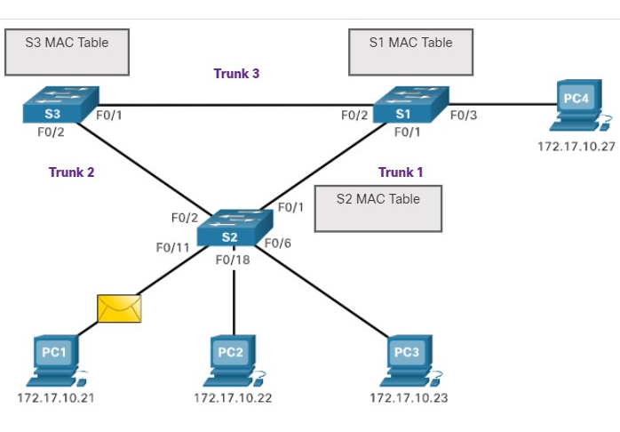

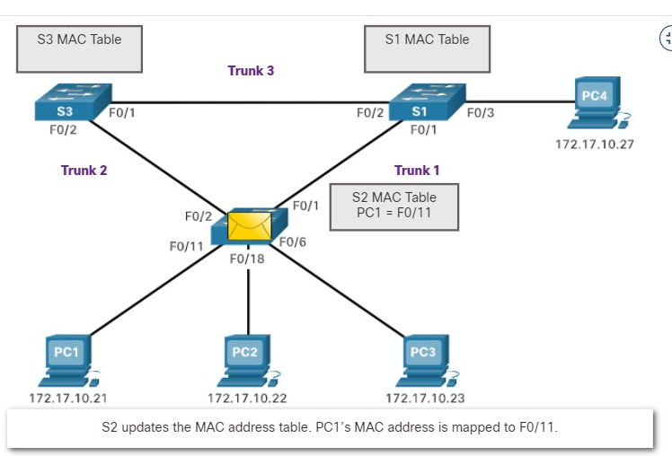

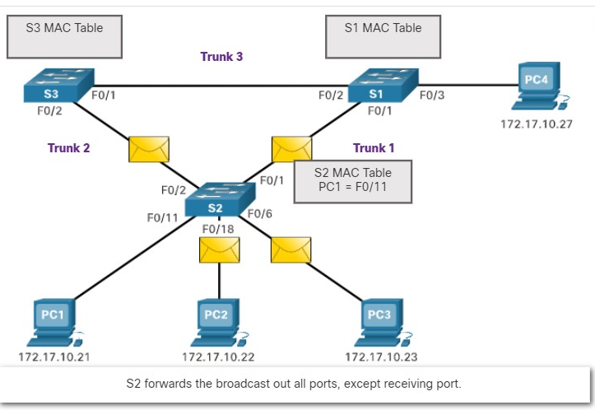

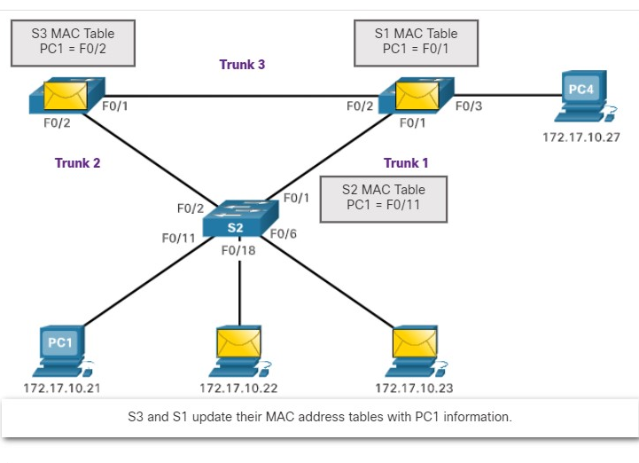

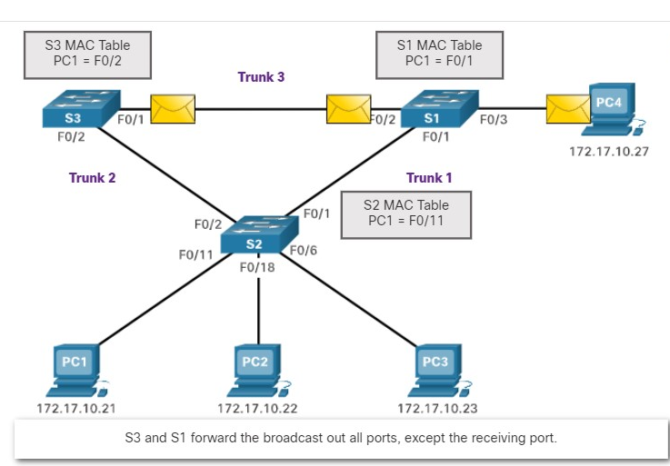

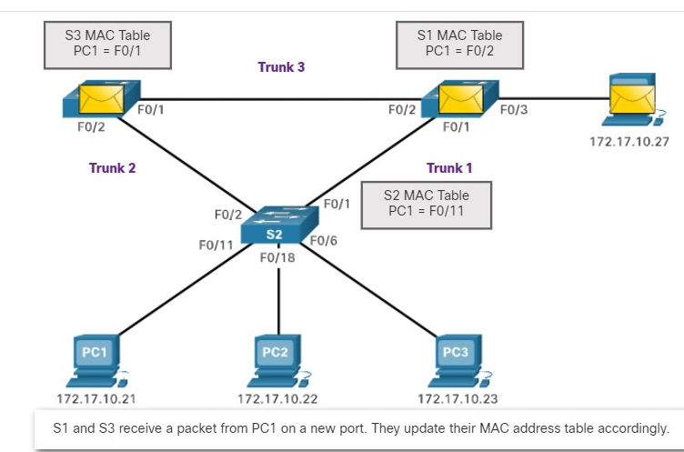

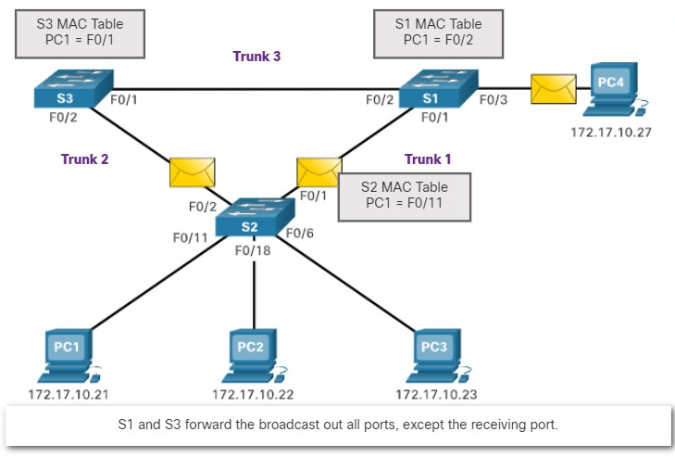

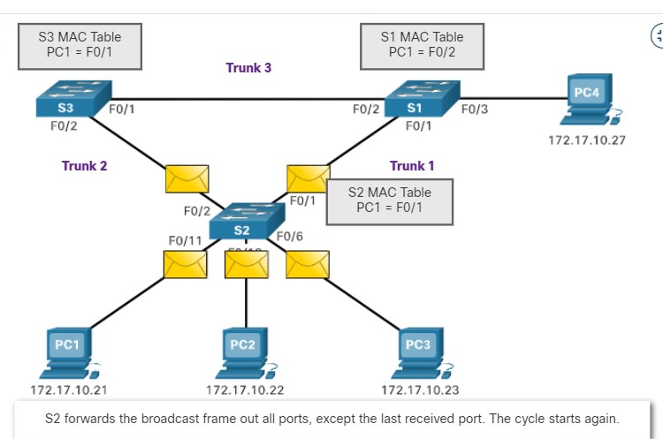

5.1.6

Broadcast Storm

A broadcast storm is an abnormally high number of broadcasts overwhelming the network during a specific amount of time.

***Broadcast storms*** can disable a network within seconds by overwhelming switches and end devices. Broadcast storms can be caused by a hardware problem such as a faulty NIC or from a Layer 2 loop in the network.

Layer 2 broadcasts in a network, such as ARP Requests are very common. A Layer 2 loop is likely to have immediate and disabling consequences on the network.

Layer 2 multicasts are typically forwarded the same way as a broadcast by the switch. So, although IPv6 packets are never forwarded as a Layer 2 broadcast, ICMPv6 Neighbor Discovery uses Layer 2 multicasts.

Click Play in the figure to view an animation that shows the increasingly adverse effects of a loop as the broadcast and unknow

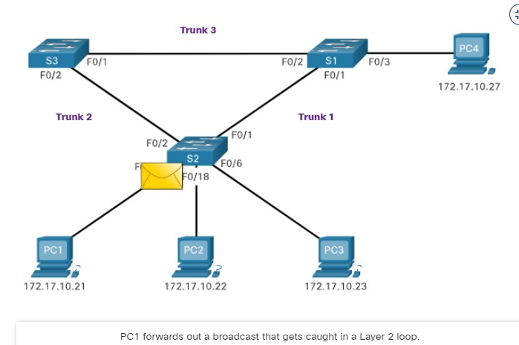

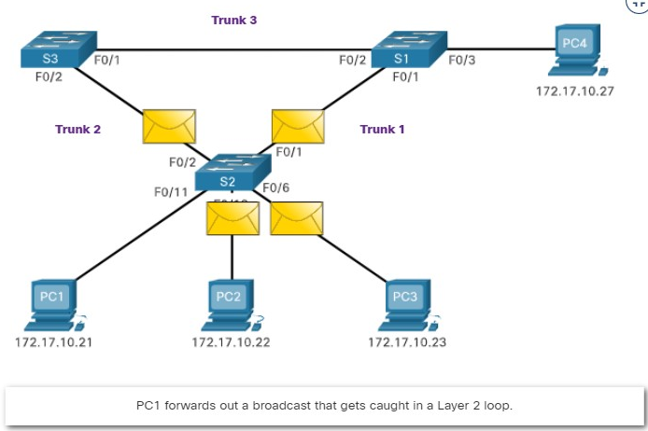

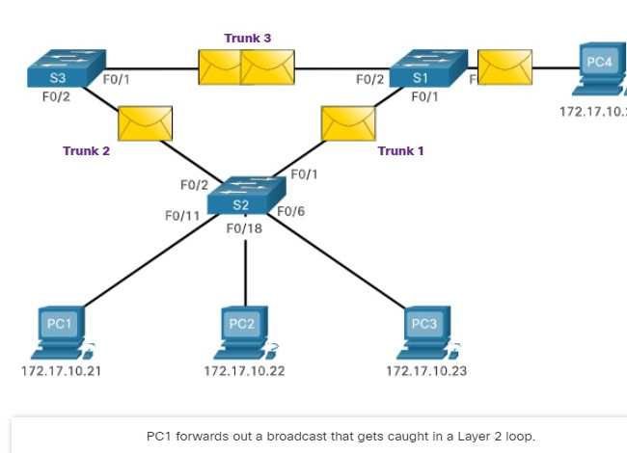

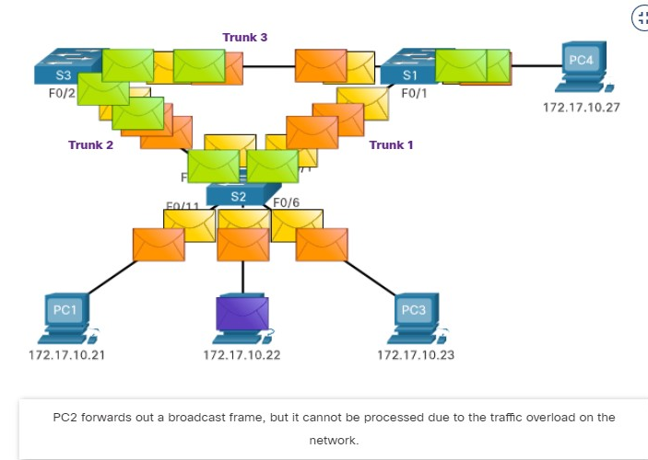

A host caught in a Layer 2 loop is not accessible to other hosts on the network. Additionally, due to the constant changes in its MAC address table, the switch does not know out of which port to forward unicast frames.

In the previous animation, the switches will have the incorrect ports listed for PC1. Any unknown unicast frame destined for PC1 loops around the network, just as the broadcast frames do. More and more frames looping around the network eventually creates a broadcast storm.

To prevent these issues from occurring in a redundant network, some type of spanning tree must be enabled on the switches. Spanning tree is enabled, by default, on Cisco switches to prevent Layer 2 loops from occurring.

5.1.7

The Spanning Tree Algorithm

STP is based on an algorithm invented by Radia Perlman while working for Digital Equipment Corporation, and published in the 1985 paper "An Algorithm for Distributed Computation of a Spanning Tree in an Extended LAN.”

Her spanning tree algorithm (STA) creates a loop-free topology by selecting a single root bridge where all other switches determine a single least-cost path.

Without the loop prevention protocol, loops would occur rendering a redundant switch network inoperable.

**STA Scenario Topology**

This STA scenario uses an Ethernet LAN with redundant connections between multiple switches.

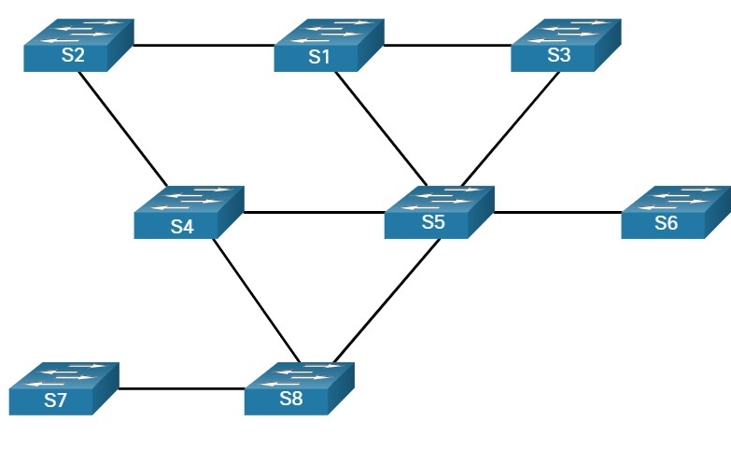

**Select the Root Bridge**

The spanning tree algorithm begins by selecting a single root bridge. The figure shows that switch S1 has been selected as the root bridge. In this topology, all links are equal cost (same bandwidth). Each switch will determine a single, least cost path from itself to the root bridge.

**Note**: The STA and STP refers to switches as bridges. This is because in the early days of Ethernet, switches were referred to as bridges.

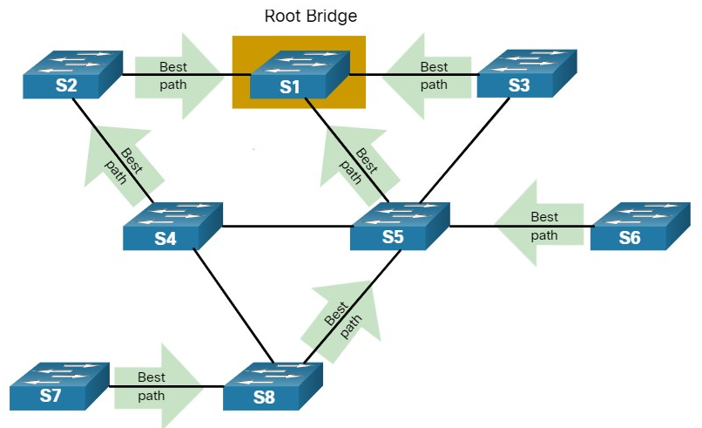

**Block Redundant Paths**

STP ensures that there is only one logical path between all destinations on the network by intentionally blocking redundant paths that could cause a loop, as shown in the figure. When a port is blocked, user data is prevented from entering or leaving that port. Blocking the redundant paths is critical to preventing loops on the network.

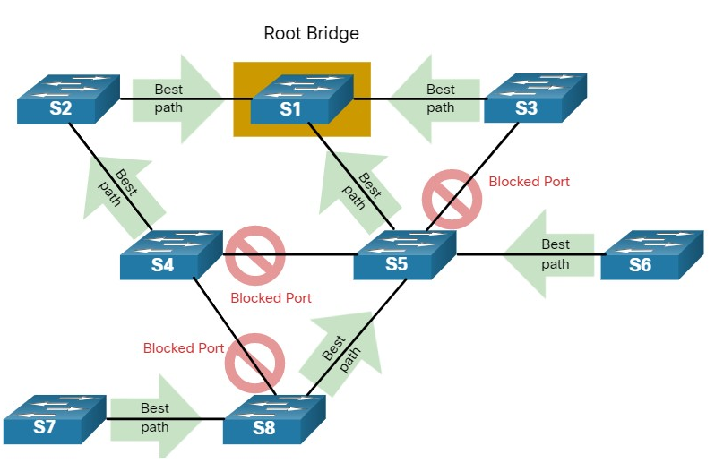

Switches S4, S5, and S8 have blocked redundant paths to the root bridge.

**Loop-Free Topology**

***A blocked port*** has the effect of making that link a non-forwarding link between the two switches, as shown in the figure. Notice that this creates a topology where each switch has only a single path to the root bridge, similar to branches on a tree that connect to the root of the tree.

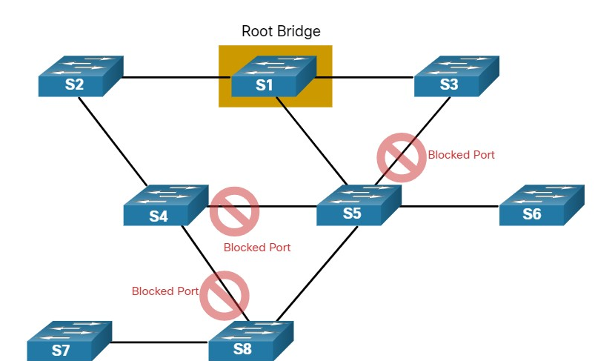

Each switch now has just one forwarding path to the root bridge.

STP prevents loops from occurring by configuring a loop-free path through the network using strategically placed "blocking-state" ports. The switches running STP are able to compensate for failures by dynamically unblocking the previously blocked ports and permitting traffic to traverse the alternate paths.

5.1.9

Packet Tracer - Investigate STP Loop Prevention(pending 5.1.9)

In this Packet Tracer activity, you will complete the following objectives:

* Create and configure a simple three switch network with STP.
* View STP operation
* Disable STP and view operation again.
* .

1. Which statement describes STP?



STP is a Layer 2 routing protocol.



STP is a Layer 3 routing protocol for Ethernet LANs.



STP is a Layer 2 loop prevention protocol for Ethernet LANs.



STP is a Layer 3 loop prevention protocol for IP networks.

***ANS: STP is used to prevent Layer 2 loops on Ethernet LANs***

2. Without STP on the Ethernet LAN, which three types of frames could cause a catastrophic loop in the network? (Choose three.)



Unicast



Unknown unicast



Multicast



Broadcast

**ANS: Without STP enabled, unknown unicast, multicast, and broadcast frames could loop *endlessly on the network, causing catastrophic network failure***

3. What device is elected by the Spanning Tree Algorithm? All other switches determine a single least-cost path to this device.



Root bridge



Dedicated bridge



Default gateway



Core switch

***ANS:* The STP algorithm elects a root bridge on the LAN. All other switches calculate the lowest cost path to the root bridge.**

**STP OPERATIONS**

5.2.1

Steps to a Loop-Free Topology

Now you know how loops are created and the basics of using spanning tree protocol to prevent them. This topic will take you, step by step, through the operation of STP. Using the STA, STP builds a loop-free topology in a four-step process:

* **Elect the root bridge.**
* **Elect the root ports.**
* **Elect designated ports.**
* **Elect alternate (blocked) ports.**

During STA and STP functions, switches use **Bridge Protocol Data Units (BPDUs) to** share information about themselves and their connections.

BPDUs are used to elect the Root Bridge, root ports, designated ports, and alternate ports.

Each BPDU contains a bridge ID (BID) that identifies which switch sent the BPDU. The BID is involved in making many of the STA decisions including root bridge and port roles.

As shown in the figure, the BID contains a priority value, an extended system ID, and the MAC address of the switch. The lowest BID value is determined by the combination of these three fields.

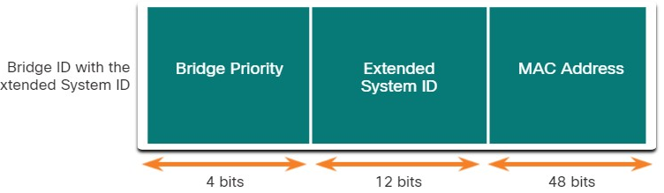

Bridge

The BID includes the Bridge Priority, the Extended System ID, and the MAC Address of the switch.

**Bridge Priority**

The default priority value for all Cisco switches is the ***decimal value 32768***. The range is 0 to 61440 in increments of 4096. A lower bridge priority is preferable. A bridge priority of 0 takes precedence over all other bridge priorities.

**Extended System ID**

The extended system ID value is a decimal value added to the bridge priority value in the BID to identify the VLAN for this BPDU.

Early implementations of IEEE 802.1D were designed for networks that did not use VLANs. There was a single common spanning tree across all switches.

For this reason, in older switches, the extended system ID was not included in the BPDUs. As VLANs became common for network infrastructure segmentation, 802.1D was enhanced to include support for VLANs, which required that the 12-bit VLAN ID be included in the BPDU frame. VLAN information is included in the BPDU frame through the use of the extended system ID.

The extended system ID allows later implementations of STP to have different root bridges for different sets of VLANs. This can allow for redundant, non-forwarding links in a STP topology for one set of VLANs to be used by a different set of VLANs using a different root bridge.

**MAC address**

When two switches are configured with the same priority and have the same extended system ID, the switch having the MAC address with the lowest value, expressed in hexadecimal, will have the lower BID.

5.2.2

1. Elect the Root Bridge

The STA designates a single switch as the root bridge and uses it as the reference point for all path calculations. Switches exchange BPDUs to build the loop-free topology beginning with selecting the root bridge.

An election process determines which switch becomes the root bridge. All switches in the broadcast domain participate in the election process. After a switch boots, it begins to send out BPDU frames every two seconds. These BPDU frames contain the BID of the sending switch and the BID of the root bridge, known as the Root ID.

The switch with the lowest BID will become the root bridge. At first, all switches declare themselves as the root bridge with their own BID set as the Root ID. Eventually, the switches learn through the exchange of BPDUs which switch has the lowest BID and will agree on one Root Bridge.

In the figure, S1 is elected the root bridge because it has the lowest BID.

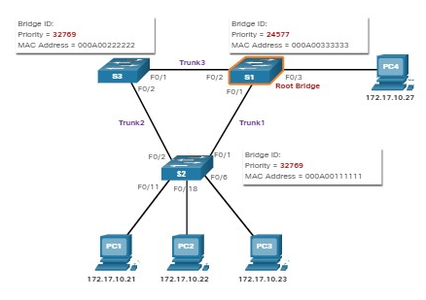

5.2.3

Impact of Default BIDs

Because the ***default BID is 32768,*** it is possible for two or more switches to have the same priority. In this scenario, where the priorities are the same, the switch with the lowest MAC address will become the root bridge.

To ensure that the root bridge decision best meets network requirements, it is recommended that the administrator configures the desired root bridge switch with a lower priority.

In the figure, all switches are configured with the same priority of 32769. Here the MAC address becomes the deciding factor as to which switch becomes the root bridge.

The switch with the ***lowest hexadecimal MAC address*** value is the preferred **root bridge.** In this example, S2 has the lowest value for its MAC address and is elected as the root bridge for that spanning tree instance.

**Note**: In the example, the priority of all the switches is 32769. The value is based on the 32768 default bridge priority and the extended system ID (VLAN 1 assignment) associated with each switch (32768+1).

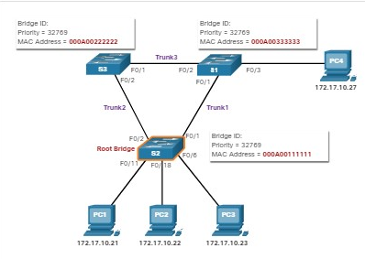

5.2.4

Determine the Root Path Cost

When the root bridge has been elected for a given spanning tree instance, the STA starts the process of determining the best paths to the root bridge from all destinations in the broadcast domain.

The path information, known as the ***internal root path cost***, is determined by the sum of all the individual port costs along the path from the switch to the root bridge.

**Note**: The BPDU includes the root path cost. This is the cost of the path from the sending switch to the root bridge.

When a switch receives the BPDU, it adds the ingress port cost of the segment to determine its internal root path cost.

The default port costs are defined by the speed at which the port operates. The table shows the default port costs suggested by IEEE.

Cisco switches by default use the values as defined by the IEEE 802.1D standard, also known as the ***short path cost***, for both STP and RSTP.

However, the IEEE standard suggests using the values defined in the IEEE-802.1w, also known as long path cost, when using 10 Gbps links and faster.

**Note**: RSTP is discussed in more detail later in this module.

| **Link Speed** | **STP Cost: IEEE 802.1D-1998** | **RSTP Cost: IEEE 802.1w-2004** |
| --- | --- | --- |
| 10 Gbps | 2 | 2,000 |
| 1 Gbps | 4 | 20,000 |
| 100 Mbps | 19 | 200,000 |
| 10 Mbps | 100 | 2,000,000 |

Although switch ports have a default port cost associated with them, the port cost is configurable. The ability to configure individual port costs gives the administrator the flexibility to manually control the spanning tree paths to the root bridge.

5.2.5

2. Elect the Root Ports

After the root bridge has been determined, the STA algorithm is used to select the root port. Every non-root switch will select one root port.

The root port is the port closest to the root bridge in terms of overall cost (best path) to the root bridge. This overall cost is known as the ***internal root path cost***.

The internal root path cost is equal to the sum of all the port costs along the path to the root bridge, as shown in the figure.

Paths with the lowest cost become preferred, and all other redundant paths are blocked. In the example, the internal root path cost from S2 to the root bridge S1 over path 1 is 19 (based on the IEEE-specified individual port cost) while the internal root path cost over path 2 is 38. Because path 1 has a lower overall path cost to the root bridge, it is the preferred path and F0/1 becomes the root port on S2.

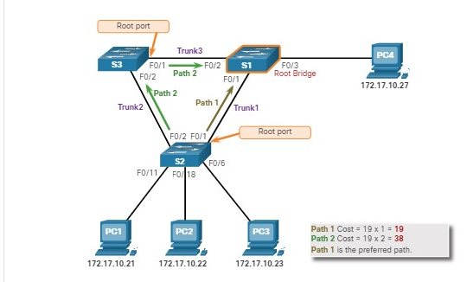

5.2.6

3. Elect Designated Ports

The loop prevention part of spanning tree becomes evident during these next two steps. After each switch selects a root port, the switches will then select designated ports.

Every segment between two switches will have one designated port. The designated port is a port on the segment (with two switches) that has the internal root path cost to the root bridge. In other words, the designated port has the best path to receive traffic leading to the root bridge.

What is not a root port or a designated port becomes an alternate or blocked port. The end result is a single path from every switch to the root bridge.

**1. Designated Ports on Root Bridge**

All ports on the root bridge are designated ports, as shown in the figure. This is because the root bridge has the lowest cost to itself.

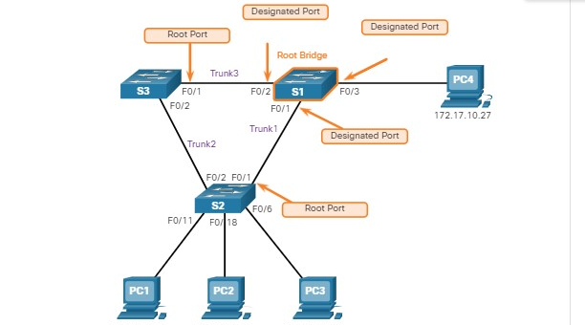

**2. Designated Port When there is a Root Port**

If one end of a segment is a root port, then the other end is a designated port. To demonstrate this, the figure shows that switch S4 is connected to S3. The Fa0/1 interface on S4 is its root port because it has the best and only path to the root bridge. The Fa0/3 interface on S3 at the other end of the segment would therefore, be the designated port.

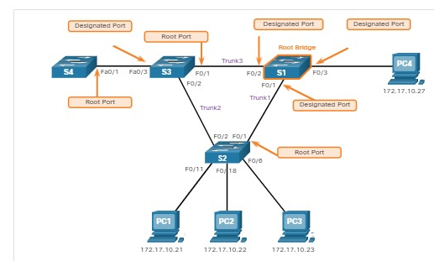

**Note**: All switch ports with end devices (hosts) attached are designated ports.

**3. Designated Port When There is No Root Port**

This leaves only segments between two switches where neither of the switches is the root bridge. In this case, the port on the switch with the least-cost path to the root bridge is the designated port for the segment.

For example, in the figure, the last segment is the one between S2 and S3. Both S2 and S3 have the same path cost to the root bridge. The spanning tree algorithm will use the bridge ID as a tie breaker. Although not shown in the figure, S2 has a lower BID. Therefore, the F0/2 port of S2 will be chosen as the designated port. Designated ports are in forwarding state.

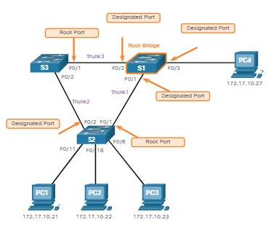

5.2.7

4. Elect Alternate (Blocked) Ports

If a port is not a root port or a designated port, then it becomes an alternate (or backup) port. Alternate ports and backup ports are in discarding or blocking state to prevent loops.

In the figure, the STA has configured port F0/2 on S3 in the alternate role. Port F0/2 on S3 is in the blocking state and will not forward Ethernet frames. All other inter-switch ports are in forwarding state. This is the loop-prevention part of STP.

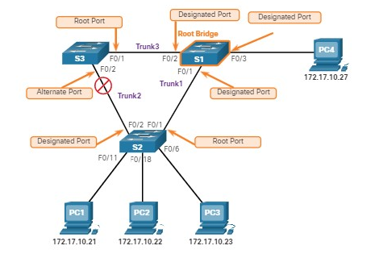

The Fa0/2 interface of S3 is not a root port or a designated port, so it becomes an alternate or blocked port.

5.2.8

## Elect a Root Port from Multiple Equal-Cost Paths

Root port and designated ports are based on the lowest path cost to the root bridge. But what happens if the switch has multiple equal-cost paths to the root bridge? How does a switch designate a root port?

When a switch has multiple equal-cost paths to the root bridge, the switch will determine a port using the following criteria:

* **Lowest sender BID**
* **Lowest sender port priority**
* **Lowest sender port ID**

**1. Lowest Sender BID**

The figure shows a topology with four switches, including switch S1 as the root bridge. Examining the port roles, port F0/1 on switch S3 and port F0/3 on switch S4 have been selected as root ports because they have the lowest cost path (root path cost) to the root bridge for their respective switches.

S2 has two ports, F0/1 and F0/2 with equal cost paths to the root bridge. In this case the bridge IDs of the neighboring switches, S3 and S4, will be used to break the tie.

This is known as the sender’s BID. S3 has a BID of 32769.5555.5555.5555 and S4 has a BID of 32769.1111.1111.1111. Because S4 has a lower BID, the F0/1 port of S2, which is the port connected to S4, will be the root port.

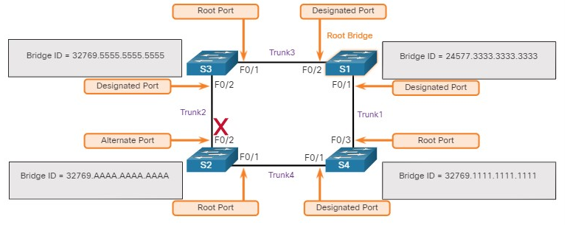

**2. Lowest Sender Port Priority**

To demonstrate these next two criteria, the topology is changed to one where two switches are connected with two equal-cost paths between them. S1 is the root bridge, so both of its ports are designated ports.

S4 has two ports with equal-cost paths to the root bridge. Because both ports are connected to the same switch, the sender’s BID (S1) is equal. So the first step is a tie.

Next on the list is the sender’s (S1) port priority. The default port priority is 128, so both ports on S1 have the same port priority. This is also a tie. However, if either port on S1 was configured with a lower port priority, S4 would put its adjacent port in forwarding state. The other port on S4 would be a blocking state.

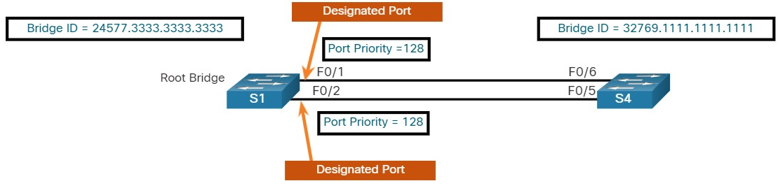

**3. Lowest Sender Port ID**

The last tie-breaker is the lowest sender’s port ID. Switch S4 has received BPDUs from port F0/1 and port F0/2 on S1. Remember the decision is based on the sender’s port ID, not the receiver’s port ID. Because the port ID of F0/1 on S1 is lower than port F0/2, the port F0/6 on switch S4 will be the root port. This is the port on S4 that is connected to the F0/1 port on S1.

Port F0/5 on S4 will become an alternate port and placed in the blocking state, which is the loop-prevention part of STP.

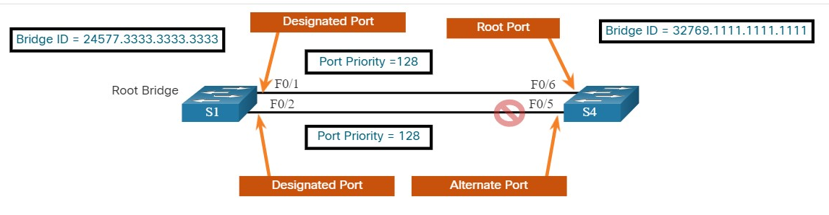

5.2.9

## STP Timers and Port States

STP convergence requires three timers, as follows:

* **Hello Timer** -The hello time is the interval between BPDUs. The default is 2 seconds but can be modified to between 1 and 10 seconds.
* **Forward Delay Timer** -The forward delay is the time that is spent in the listening and learning state. The default is 15 seconds but can be modified to between 4 and 30 seconds.
* **Max Age Timer** -The max age is the maximum length of time that a switch waits before attempting to change the STP topology. The default is 20 seconds but be modified to between 6 and 40 seconds.

**Note**: The default times can be changed on the root bridge, which dictates the value of these timers for the STP domain.

STP facilitates the logical loop-free path throughout the broadcast domain. The spanning tree is determined through the information learned by the exchange of the BPDU frames between the interconnected switches.

If a switch port transitions directly from the blocking state to the forwarding state without information about the full topology during the transition, the port can temporarily create a data loop. For this reason, STP has five ports states, four of which are operational port states as shown in the figure. The disabled state is considered non-operational.

**Note**: To avoid problems with STP, IEEE recommends a maximum diameter of seven switches when using the default STP timers.

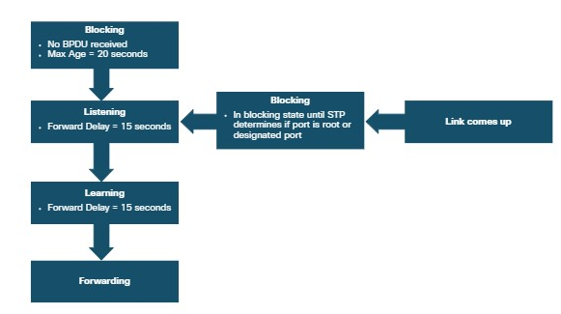

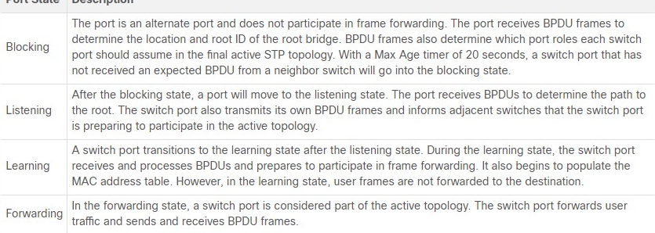



5.2.10

Operational Details of Each Port State

The table summarizes the operational details of each port state.

| **Port State** | **BPDU** | **MAC Address Table** | **Forwarding Data Frames** |
| --- | --- | --- | --- |
| Blocking | Receive only | No update | No |
| Listening | Receive and send | No update | No |
| Learning | Receive and send | Updating table | No |
| Forwarding | Receive and send | Updating table | Yes |
| Disabled | None sent or received | No update | No |

5.2.11

Per-VLAN Spanning Tree

Up until now, we have discussed STP in an environment where there is only one VLAN. However, STP can be configured to operate in an environment with multiple VLANs.

In Per-VLAN Spanning Tree (PVST) versions of STP, there is a root bridge elected for each spanning tree instance.

This makes it possible to have different root bridges for different sets of VLANs. STP operates a separate instance of STP for each individual VLAN. If all ports on all switches are members of VLAN 1, then there is only one spanning tree instance.

1. By default (without any configuration on a switch), what will determine which switch is the root bridge?



The bridge priority



The extended system ID



The MAC address of the switch



The bridge ID

***ANS: Without configuration changes, all switches will have the default STP priority of 32,768. If all priorities are the same, the switch with the lowest MAC address value will become the root bridge.***

1. The root bridge will be the switch with the:



Lowest bridge ID



Highest bridge ID



Lowest port priority



Highest port priority

***ANS: The switch with the lowest bridge ID will become the root bridge.***

1. The port closest to the root bridge in terms of least overall cost (best path) to the root bridge is the:



Designated port



Blocked port or non-designated port



Root port



Routed Port

***ANS: The root port is the switch port on a switch with the lowest path cost to the root bridge***.

1. The port on the segment (with two switches) that has the lowest path cost to the root bridge is the:



Designated port



Blocked port or non-designated port



Root port



Routed Port

**ANS: The designated port is the switch port on a segment with the lowest path cost to the root bridge.**

1. Which of the following ports will forward Ethernet frames? (Choose two.)



Designated port



Blocked port or non-dedicated port



Root port

***ANS: Designated ports and root ports will forward Ethernet frames.***

1. The sum of individual port costs along the path from the switch to the root bridge is known as the:



Least cost path



Shortest path cost



Best path cost



Root path cost

***ANS: The root path cost is the sum of individual port costs along the path from the switch to the root bridge.***

1. How often does a switch send a BPDU?



Every 2 seconds



Every 15 seconds



Every 20 seconds



Only when there is a change in the topology

***SANS: BPDUs are send every 2 seconds by default.***

**STP EVOLUTION**

5.3.1

Different Versions of STP

This topic details the many different versions of STP and other options for preventing loops in your network.

Up to now, we have used the term Spanning Tree Protocol and the acronym STP, which can be misleading.

Many professionals generically use these to refer to the various implementations of spanning tree, such as ***Rapid Spanning Tree Protocol (RSTP)*** and ***Multiple Spanning Tree Protocol (MSTP).*** In order to communicate spanning tree concepts correctly, it is important to refer to the implementation or standard of spanning tree in context.

The latest standard for spanning tree is contained in IEEE-802-1D-2004, the IEEE standard for Local and metropolitan area networks:

Media Access Control (MAC) Bridges. This version of the standard states that switches and bridges that comply with the standard will use Rapid Spanning Tree Protocol (RSTP) instead of the older STP protocol specified in the original 802.1d standard.

In this curriculum, when the original Spanning Tree Protocol is the context of a discussion, the phrase “original 802.1D spanning tree” is used to avoid confusion. Because the two protocols share much of the same terminology and methods for the loop-free path, the primary focus will be on the current standard and the Cisco proprietary implementations of STP and RSTP.

Several varieties of spanning tree protocols have emerged since the original IEEE 802.1D specification, as shown in the table.

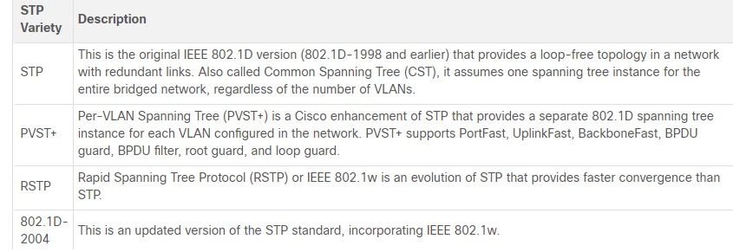

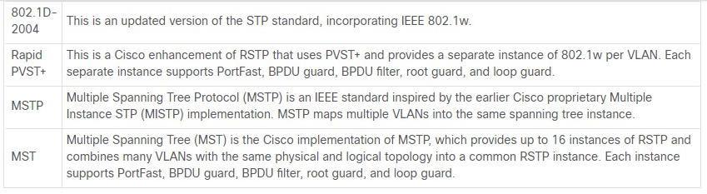

A network professional, whose duties include switch administration, may be required to decide which type of spanning tree protocol to implement.

Cisco switches running IOS 15.0 or later, run PVST+ by default. This version incorporates many of the specifications of IEEE 802.1D-2004, such as alternate ports in place of the former non-designated ports.

Switches must be explicitly configured for rapid spanning tree mode in order to run the rapid spanning tree protocol.

5.3.2

RSTP Concepts

RSTP (IEEE 802.1w) supersedes the original 802.1D while retaining backward compatibility. The 802.1w STP terminology remains primarily the same as the original IEEE 802.1D STP terminology.

Most parameters have been left unchanged. Users that are familiar with the original STP standard can easily configure RSTP. The same spanning tree algorithm is used for both STP and RSTP to determine port roles and topology.

RSTP increases the speed of the recalculation of the spanning tree when the Layer 2 network topology changes.

RSTP can achieve much faster convergence in a properly configured network, sometimes in as little as a few hundred milliseconds. If a port is configured to be an alternate port it can immediately change to a forwarding state without waiting for the network to converge.

**Note**: Rapid PVST+ is the Cisco implementation of RSTP on a per-VLAN basis. With Rapid PVST+ an independent instance of RSTP runs for each VLAN.

5.3.3

RSTP Port States and Port Roles

The port states and port roles between STP and RSTP are similar.

**STP and RSTP Port States**

As shown in the figure, there are only three port states in RSTP that correspond to the three possible operational states in STP. The 802.1D disabled, blocking, and listening states are merged into a unique 802.1w discarding state.

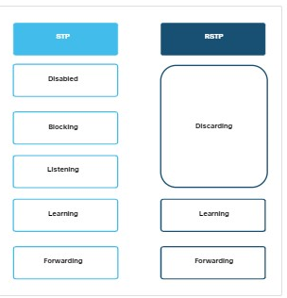

**STP and RSTP Port Roles**

As shown in the figure, root ports and designated ports are the same for both STP and RSTP. However, there are two RSTP port roles that correspond to the blocking state of STP. In STP, a blocked port is defined as not being the designated or root port. RSTP has two port roles for this purpose.

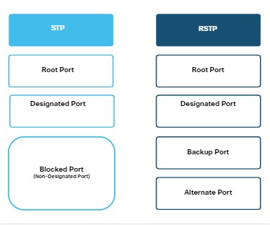

**RSTP Alternate and Backup Ports**

As shown in the figure, the alternate port has an alternate path to the root bridge. The backup port is a backup to a shared medium, such as a hub. A backup port is less common because hubs are now considered legacy devices.

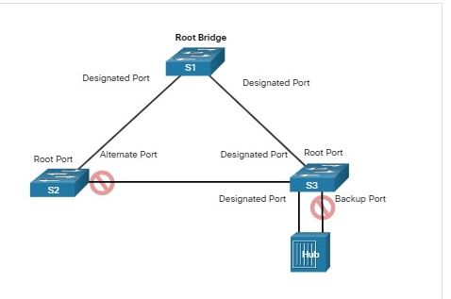

5.3.4

Port Fast and BPDU Guard

When a device is connected to a switch port or when a switch powers up, the switch port goes through both the listening and learning states, each time waiting for the Forward Delay timer to expire.

This delay is 15 seconds for each state, listening and learning, for a total of 30 seconds. This delay can present a problem for DHCP clients trying to discover a DHCP server. DHCP messages from the connected host will not be forwarded for the 30 seconds of Forward Delay timers and the DHCP process may timeout. The result is that an IPv4 client will not receive a valid IPv4 address.

**Note**: Although this may occur with clients sending ICMPv6 Router Solicitation messages, the router will continue to send ICMPv6 Router Advertisement messages so the device will know how to obtain its address information.

When a switch port is configured with ***PortFast,*** that port transitions from blocking to forwarding state immediately, bypassing the usual 802.1D STP transition states (the listening and learning states) and avoiding a 30 second delay.

You can use PortFast on access ports to allow devices connected to these ports, such as DHCP clients, to access the network immediately, rather than waiting for IEEE 802.1D STP to converge on each VLAN.

Because the purpose of PortFast is to minimize the time that access ports must wait for spanning tree to converge, it should only be used on access ports. If you enable PortFast on a port connecting to another switch, you risk creating a spanning tree loop. PortFast is only for use on switch ports that connect to end devices.

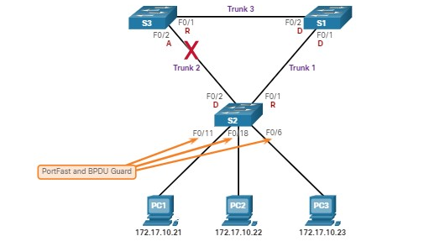

In a valid PortFast configuration, BPDUs should never be received on PortFast-enabled switch ports because that would indicate that another bridge or switch is connected to the port.

This potentially causes a spanning tree loop. To prevent this type of scenario from occurring, Cisco switches support a feature called ***BPDU guard.***

When enabled, BPDU guard immediately puts the switch port in an errdisabled (error-disabled) state on receipt of any BPDU.

This protects against potential loops by effectively shutting down the port. The BPDU guard feature provides a secure response to invalid configurations because an administrator must manually put the interface back into service.

5.3.5

Alternatives to STP

STP was and still is an Ethernet loop-prevention protocol. Over the years, organizations required greater resiliency and availability in the LAN. Ethernet LANs went from a few interconnected switches connected to a single router, to a sophisticated hierarchical network design including access, distribution and core layer switches, as shown in the figure.

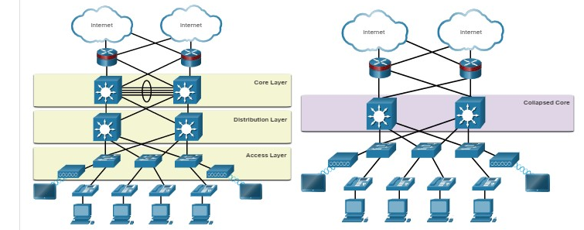

Depending on the implementation, Layer 2 may include not only the access layer, but also the distribution or even the core layers. These designs may include hundreds of switches, with hundreds or even thousands of VLANs. STP has adapted to the added redundancy and complexity with enhancements, as part of RSTP and MSTP.

An important aspect to network design is fast and predictable convergence when there is a failure or change in the topology. Spanning tree does not offer the same efficiencies and predictabilities provided by routing protocols at Layer 3. The figure shows a traditional hierarchical network design with the distribution and core multilayer switches performing routing.

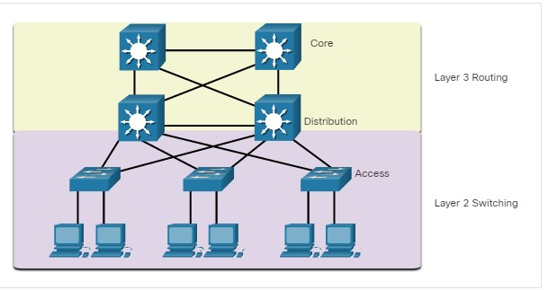

Layer 3 routing allows for redundant paths and loops in the topology, without blocking ports. For this reason, some environments are transitioning to Layer 3 everywhere except where devices connect to the access layer switch. In other words, the connections between access layer switches and distribution switches would be Layer 3 instead of Layer 2, as shown in the next figure.

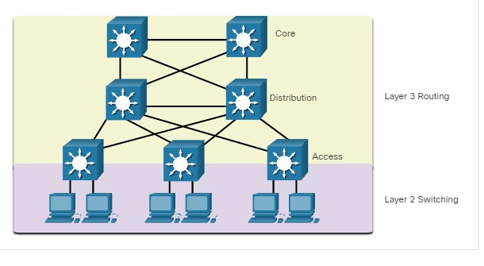

Although STP will most likely continue to be used as a loop prevention mechanism in the enterprise, on access layer switches, other technologies are also being used, including the following:

* Multi System Link Aggregation (MLAG)
* Shortest Path Bridging (SPB)
* Transparent Interconnect of Lots of Links (TRILL)

**Note**: These technologies are beyond the scope of this course.

1. Which three STP port states are merged into the RSTP discarding port state? (Choose three.)



disabled



blocking



listening



learning



Forwarding

***ANS: The STP disabled, blocking, and listening states are all merged into the RSTP discarding state.***

2. Which protocol was designed to bring faster convergence to STP?



PortFast



RSTP



PVST



MSTP

***ANS: RSTP is an evolution of STP that provides faster convergence than the original STP 802.1D specification.***

3. Which technology solves the problem of a device being unable to get an IPv4 address from a DHCP server due to STP forwarding delay timers?



PortFast



BPUD guard



PVST



MSTP

**ANS:** ***When enabled on a switch port, PortFast allows a port to transition from blocking to forwarding state immediately so that DHCP client requests are not delayed reaching the DHCP server.***

5.4.1

## What did I learn in this module?

**Purpose of STP**

Redundant paths in a switched Ethernet network may cause both physical and logical Layer 2 loops.

A Layer 2 loop can result in

* **MAC address table instability,**
* **saturation,**
* **High CPU utilization on switches and end-devices.**

This results in the network becoming unusable. Unlike the Layer 3 protocols, IPv4 and IPv6, Layer 2 Ethernet does not include a mechanism to recognize and eliminate endlessly looping frames.

Ethernet LANs require a loop-free topology with a single path between any two devices. STP is a loop-prevention network protocol that allows for redundancy while creating a loop-free Layer 2 topology.

Without STP, Layer 2 loops can form, causing broadcast, multicast and unknown unicast frames to loop endlessly, bringing down a network. A broadcast storm is an abnormally high number of broadcasts overwhelming the network during a specific amount of time.

Broadcast storms can disable a network within seconds by overwhelming switches and end devices. STP is based on an algorithm invented by Radia Perlman. Her spanning tree algorithm (STA) creates a loop-free topology by selecting a single root bridge where all other switches determine a single least-cost path.

**STP Operations**

Using the STA, STP builds a loop-free topology in a four-step process:

* **elect the root bridge,**
* **elect the root ports,**
* **elect designated ports,**
* **Elect alternate (blocked) ports.**

During STA and STP functions, switches use BPDUs to share information about themselves and their connections.

BPDUs are used to elect the root bridge, root ports, designated ports, and alternate ports.

Each BPDU contains a BID that identifies the switch that sent the BPDU. The BID is involved in making many of the STA decisions including root bridge and port roles.

The BID contains a priority value, the MAC address of the switch, and an extended system ID. The lowest BID value is determined by the combination of these three fields.

The switch with the lowest BID will become the root bridge. Because the default BID is 32,768 it is possible for two or more switches to have the same priority. In this scenario, where the priorities are the same, the switch with the lowest MAC address will become the root bridge.

When the root bridge has been elected for a given spanning tree instance, the STA determines the best paths to the root bridge from all destinations in the broadcast domain.

The path information, known as the ***internal root path cost,*** is determined by the sum of all the individual port costs along the path from the switch to the root bridge.

After the root bridge has been determined the STA algorithm selects the root port. The root port is the port closest to the root bridge in terms of overall cost, which is called the internal root path cost. After each switch selects a root port, switches will select designated ports.

The designated port is a port on the segment (with two switches) that has the internal root path cost to the root bridge. If a port is not a root port or a designated port, then it becomes an alternate (or backup) port.

Alternate ports and backup ports are in discarding or blocking state to prevent loops. When a switch has multiple equal-cost paths to the root bridge, the switch will determine a port using the following criteria:

* lowest sender BID,
* then the lowest sender port priority,
* finally the lowest sender port ID.

STP convergence requires three timers:

* **the hello timer,**
* **the forward delay timer,**
* **the max age timer.**

Port states are

* **blocking,**
* **listening,**
* **learning,**
* **forwarding,**
* **disabled.**

In PVST versions of STP, there is a root bridge elected for each spanning tree instance. This makes it possible to have different root bridges for different sets of VLANs.

**Evolution of STP.**

The term Spanning Tree Protocol and the acronym STP can be misleading. STP is often used to refer to the various implementations of spanning tree, such as RSTP and MSTP.

RSTP is an evolution of STP that provides faster convergence than STP. RSTP port states are learning, forwarding and discarding.

PVST+ is a Cisco enhancement of STP that provides a separate spanning tree instance for each VLAN configured in the network.

PVST+ supports PortFast, UplinkFast, BackboneFast, BPDU guard, BPDU filter, root guard, and loop guard.

Cisco switches running IOS 15.0 or later, run PVST+ by default. Rapid PVST+ is a Cisco enhancement of RSTP that uses PVST+ and provides a separate instance of 802.1w per VLAN.

When a switch port is configured with PortFast, that port transitions from blocking to forwarding state immediately, bypassing the STP listening and learning states and avoiding a 30 second delay.

Use PortFast on access ports to allow devices connected to these ports, such as DHCP clients, to access the network immediately, rather than waiting for STP to converge on each VLAN.

Cisco switches support a feature called BPDU guard which immediately puts the switch port in an error-disabled state upon receipt of any BPDU to protect against potential loops

. Over the years, Ethernet LANs went from a few interconnected switches that were connected to a single router, to a sophisticated hierarchical network design. Depending on the implementation, Layer 2 may include not only the access layer, but also the distribution or even the core layers. These designs may include hundreds of switches, with hundreds or even thousands of VLANs. STP has adapted to the added redundancy and complexity with enhancements as part of RSTP and MSTP. Layer 3 routing allows for redundant paths and loops in the topology, without blocking ports. For this reason, some environments are transitioning to Layer 3 everywhere except where devices connect to the access layer switch.

1. Which port state will switch ports immediately transition to when configured for PortFast?

Topic 5.3.0 - PortFast allows a switch port to bypass the listening and learning states and transition immediately to the forwarding state.



blocking



forwarding



listening



learning

1. After the election of the root bridge has been completed, how will switches find the best paths to the root bridge?

Topic 5.2.0 - After the election of a root bridge has occurred, each switch will have to determine the best path to the root bridge from its location. The path is determined by summing the individual port costs along the path from each switch port to the root bridge.



Each switch will analyze the BID of all neighbors to reach the root and use the path through the lowest BID neighbors.



Each switch will analyze the port states of all neighbors and use the designated ports to forward traffic to the root.



Each switch will analyze the sum of the hops to reach the root and use the path with the fewest hops.



Each switch will analyze the sum of all port costs to reach the root and use the path with the lowest cost.

1. Which is the default STP operation mode on Cisco Catalyst switches?

Topic 5.3.0 -



PVST+



MSTP



MST



RSTP



Rapid PVST+

1. What value determines the root bridge when all switches connected by trunk links have default STP configurations?

Topic 5.2.0 - When all switches are configured with the same default bridge priority, the MAC address becomes the deciding factor for the election of the root bridge. All links on the same VLAN will also have the same extended system ID so this will not contribute to determine which switch is the root for that VLAN.



bridge priority



VLAN ID



MAC address



extended system ID

1. During the implementation of Spanning Tree Protocol, all switches are rebooted by the network administrator. What is the first step of the spanning-tree election process?

Topic 5.2.0 - After a Cisco switch boots, it will send out BPDUs containing its individual BID and the root ID for the network. By default, the initial root ID at bootup will be the ID of that individual switch. After a root bridge is elected, port states and paths are chosen.



Each switch determines what port to block to prevent a loop from occurring.



Each switch with a lower root ID than its neighbor will not send BPDUs.



All the switches send out BPDUs advertising themselves as the root bridge.



Each switch determines the best path to forward traffic.

1. Which two concepts relate to a switch port that is intended to have only end devices attached and intended never to be used to connect to another switch? (Choose two.)

Topic 5.3.0 - The RSTP edge port concept corresponds to the PVST+ PortFast feature. An edge port connects to an end station and assumes that the switch port does not connect to another switch. RSTP edge ports should immediately transition to the forwarding state, thereby skipping the time-consuming 802.1D listening and learning port states. PVST+ is the default spanning-tree configuration for a Cisco Catalyst switch. The bridge ID (BID) is used to determine the root bridge on a network and includes the bridge priority, the extended system ID, and the MAC address.



PVST+



PortFast



edge port



extended system ID



bridge ID

1. Which three port states are used by Rapid PVST+? (Choose three.)

Topic 5.3.0 - The Rapid PVST+ port states are discarding, learning, and forwarding.



learning



blocking



discarding



trunking



forwarding



listening

1. When PVST is running over a switched network, which port state can participate in BPDU frame forwarding based on BPDUs received, but does not forward data frames?

Topic 5.2.0 - Ports in the blocking state are nondesignated ports and do not participate in frame forwarding. Ports in the listening state can participate in BPDU frame forwarding according to received BPDU frames, but do not forward data frames. Ports in the forwarding state forward data frames and send and receive BPDU frames. Ports in the disabled state are administratively disabled.



forwarding



disabled



blocking



listening

1. Which STP port role is adopted by a switch port if there is no other port with a lower cost to the root bridge?

Topic 5.2.0 - The root port is the port with the lowest cost to reach the root bridge.



root port



alternate



designated port



disabled port

1. Which two statements describe a switch port that is configured with PortFast? (Choose two.)

Topic 5.3.0 - A port that is configured with PortFast will immediately transition from blocking to the forwarding state. PortFast should only be configured on switch ports that support end devices, so no BPDUs should ever be received through a port that is configured with PortFast. Configuring a port with PortFast supports DHCP because PortFast will speed up the transition from blocking to forwarding. Without PortFast, an end device may begin to issue DHCP requests before the port has transitioned to the forwarding state.



The switch port immediately transitions from blocking to the forwarding state.



The switch port immediately processes any BPDUs before transitioning to the forwarding state.



The switch port should never receive BPDUs.



The switch port immediately transitions from the listening to the forwarding state.



The switch port sends DHCP requests before transitioning to the forwarding state.

1. What is one way to correct a spanning tree failure?

Topic 5.3.0 - An action that can be taken when there is a spanning tree failure in a Layer 2 network is to remove all redundant links in the failed segment of the network. This will eliminate the loops in the topology allowing for a normalization of the traffic and CPU loads. The next step would be to investigate the failure of STP on the redundant links and fix these issues prior to restoring these links.



Manually remove redundant links in the switched network.



Insert redundant links to replace the failed STP links.



Replace all instances of STP with RSTP.



Replace the cables on failed STP links.

1. What additional information is contained in the 12-bit extended system ID of a BPDU?

Topic 5.2.0 - The BPDU has three fields; the bridge priority, the extended system ID, and the MAC address. The extended system ID contains 12 bits that identify the VLAN ID.



port ID



MAC address



IP address



VLAN ID

1. An administrator is troubleshooting a switch and wants to verify if it is a root bridge. What command can be used to do this?

Topic 5.1.0 - Of all the commands that are listed, only the correct option, **show spanning-tree,** displays STP root bridge information.



**show startup-config**



**show vlan**



**show running-config**



**show spanning-tree**

1. What is an accurate description of  redundancy?

Topic 5.1.0 - Redundancy attempts to remove any single point of failure in a network by using multiple physically cabled paths between switches in the network.



configuring a router with a complete MAC address database to ensure that all frames can be forwarded to the correct destination



designing a network to use multiple virtual devices to ensure that all traffic uses the best path through the internetwork



designing a network to use multiple paths between switches to ensure there is no single point of failure



configuring a switch with proper security to ensure that all traffic forwarded through an interface is filtered